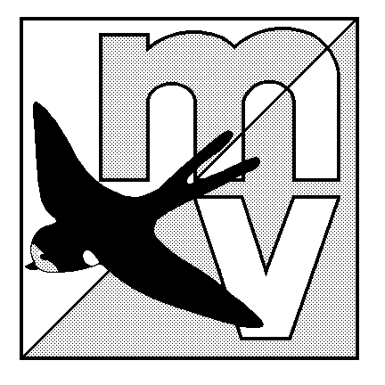
MOLE VALLEY ORIENTEERING CLUB
(Affiliated to the British Orienteering Federation)

LIMITED DISTRICT EVENT
The Nower, Dorking
Monday 30th May 2005
(In conjunction with The 28th Surrey Hill Races)

Venue Small but interesting area of mostly runnable woodland, with many paths. All facilities are close together, and there is an ideal grassy area to have a picnic on after your run!

Car Park The Powell Corderoy School, Dorking, Surrey. OS Map 187, at GR 157487.
Follow ‘Hill Race’ signs from South end of Dorking one-way system.

Map 1:5000, 5m contours
Registration 10.00 - 12.00 Entry on the day only.

Starts 10.30 - 12.30 Courses close 14:30

Courses & Yellow, Orange and Green only. The event will be using SportIdent electronic
Punching punching (hire charge £1).

Fees Seniors £4.00. Juniors £1.50.

Facilities Squash, dogs welcome. Toilets available in Dorking town centre, go before you come please!

Officials Organiser: Mark Rowe 020 8844 1370 mark.rowe@fsmail.net
Planner: Mark Cheesman Controller: Simon Ling

MV Web Site http://www.mvoc.org/

Safety Whistles recommended.

Competitors participate at this event at their own risk

